Introducing the RxLabelScanner!

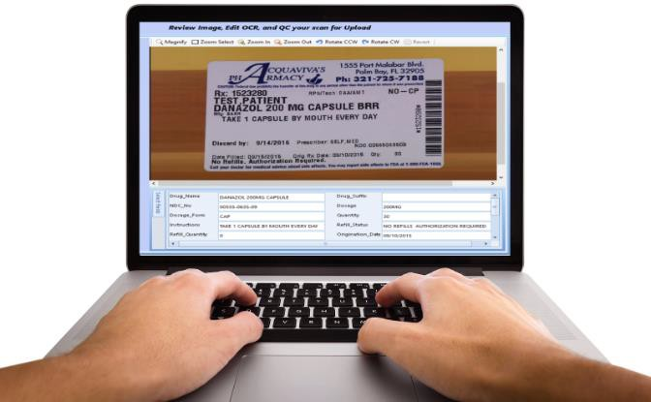
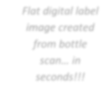
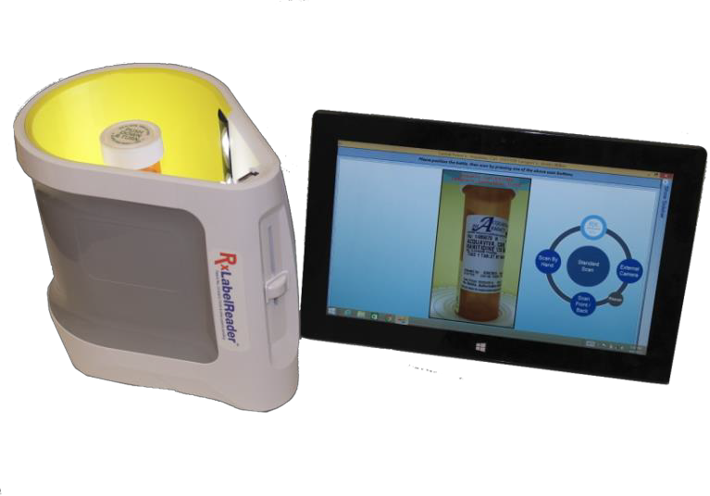
Saves time, increases accuracy, reduces legal liability!

Scan bottle
Key Image

Flat 2D digital label image created from 3D bottle scan… in seconds!!!

Simulated client data entry screen from label image

Use both hands to key from high quality, enlarged flat images on your computer screen!

Holding a prescription bottle in one hand while writing down data with the other, or “pecking” with one finger at a computer key pad is cumbersome and error prone!
Prescription data must be copied accurately from medication labels even though they are often hard to read due to small or faint print, unfamiliar and often similar confusing drug names, and unfamiliar form layouts.
Rx label information can be transcribed faster and more accurately from a 2D image that you can attach electronically to your patient’s medical record and post to the cloud!

Introducing the patented RxLabelReader™-Lite! Scanning patients’ drug containers creates sharp, two dimensional flat digital images. These label images are enhanced and enlarged on the computer screen for best readability.
The patented RxLabelReader™ enables one to use both hands to key prescription data from enlarged images on your screen.
- Transfer prescription label image files directly
to your patient’s electronic medical records file.
- Reduce your burden of risk management, reduce transcription errors! Proof of compliance reduces legal liability and related insurance costs.

How does it work and what does it cost?

The RxLabelReader comes in a carrying case offering protection and easy portability.
The unit connects to a Microsoft Windows computer with a USB connector cable. A plug-in battery compartment at the bottom of the scanner unit houses a supplied battery pack that charges when the Reader is connected to a wall outlet.
Pill bottles are inserted into the Reader by placing prescription bottles onto a pre-grooved platen manufactured for various cylindrical bottle sizes (other bottle sizes may be accommodated by turning over the grooved platen). The patented RxLabelReader software rotates the drug container 360+ degrees and in seconds compiles a high quality flat image on the computer screen.
The ability to use both hands on the keyboard while looking at high quality, enlarged prescription label images on the screen significantly increases operator accuracy and speed.

Backup images:
The RxLabelReader creates a multiple view backup image file automatically for each digitally compiled image for quality control or reference.

Image and Data Transfer:
While label image files are created and stored in the RxLabelReader file directory, customers are required to manage their image repository according to HIPAA standards and may transfer the supporting image files into the patient’s electronic medical record (EMR).
Output: JPEG files

PC Specifications:
The RxLabelReader system works with a Microsoft Windows laptop, tablet or PC. Processor require-ments are Intel i5 (or equivalent) and above with a minimum of 4GB of memory (preferably at least 6GB for best performance) and 50+ GB of free disk space.

Accessories included with the RxLabelReader are:
A plug-in external camera allows picture taking of documents such as ID cards, medical records, HIPAA privacy authorization forms, and patient portraits if desired.

ADDICTION REHABILITATION MARKET
RxLabelReader-Lite Cost: $995.00 *Mention Discount Code: VRM018 SAVE $300!
(Regularly $1295.00)
First year hardware and software support included!
Second year support cost: $235.00
Wire, Check or Cr. Card
(MC, VISA, AMEX)
Contact us now:
email: sales@versasoftware.com

VERSAIMAGE SOFTWARE CORPORATION www.versasoftware.com/rxlabelscanner sales@versasoftware.com
100 Orndorf Drive #840, Brighton MI 48116 Tel: 810-225-9720 Ext. 1

